1️⃣ What is Python? Why is it popular in AI & Data Science?
Python is a high-level, interpreted programming language that is easy to read and write.
A high-level programming language is designed to be easy for humans to read and write.

Characteristics:
- Uses English-like words
- Hides hardware details (CPU, memory, registers)
- Easier to learn and debug
An interpreted language runs code line by line using an interpreter, instead of compiling the whole program at once.
Errors are shown immediately at the line where they occur
Python is a high-level, interpreted programming language
It means:
- ✅ Easy to understand (high-level)
- ✅ No need to manage hardware details
- ✅ Executes code line by line (interpreted)
- ✅ Faster development, slower execution than compiled languages

Why popular in AI & Data Science?
- Simple syntax (easy to learnand understand)
- Huge libraries: NumPy, Pandas, Scikit-learn, TensorFlow, PyTorch
- Strong community support
- Good for data handling, ML, DL, visualization

2️⃣ Difference between List, Tuple, Set, Dictionary

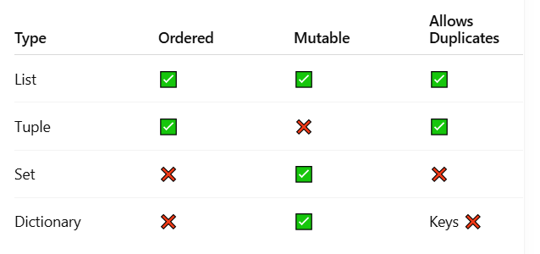

3️⃣ What are variables and data types in Python?
Variable → stores data in memory
Data type → type of data stored
Common data types:
- int → 10
- float → 3.14
- string → "AI"
- bool → True
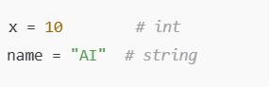

4️⃣ Difference between == and =
Operator | Meaning
= | Assignment
== | Comparison
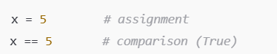

5️⃣ Explain if, elif, and else
Used for decision making.
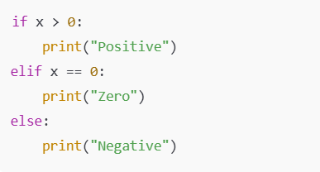

6️⃣ What is a function? Why do we use functions?

A function is a block of reusable code that performs a specific task.

Why use?
- Code reusability-Write once, use many times.
- Clean & readable code
- Avoid repetition
- Easy debugging
- Modularity-Big programs are broken into small parts.
- Saves time & effort

🔹 Types of functions in Python
- Built-in functions
print(), len(), type()
- User-defined functions
Created by programmer using def
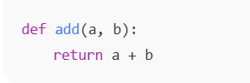
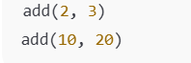

7️⃣ Difference between for loop and while loop
For loop | While loop
Used when count is known advaced | Used when the number of iterations is NOT known in advance and it is condition based
Iterates over sequence | Runs until condition false
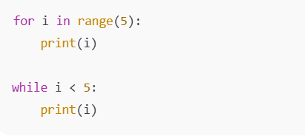
8️⃣ What is a module? Example
A module is a file that contains Python code (functions, variables, classes) which can be reused in other programs.
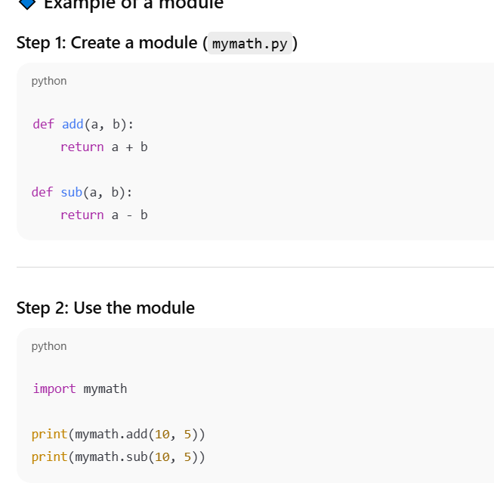

🔹 Built-in modules (already available)
Python comes with many built-in modules:
- math
- random
- datetime
- os
Example:
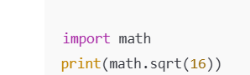

9️⃣ What is exception handling?
Exception handling is a way to handle runtime errors gracefully so the program does not crash.

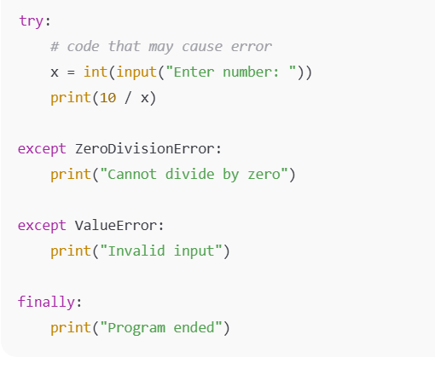

🔟 What is pip?

pip is a tool used to install, update, and manage Python packages (libraries).
pip = Python package installer
Used to install external libraries.

